Wakefield District Economic Wellbeing Strategy 2024-2029
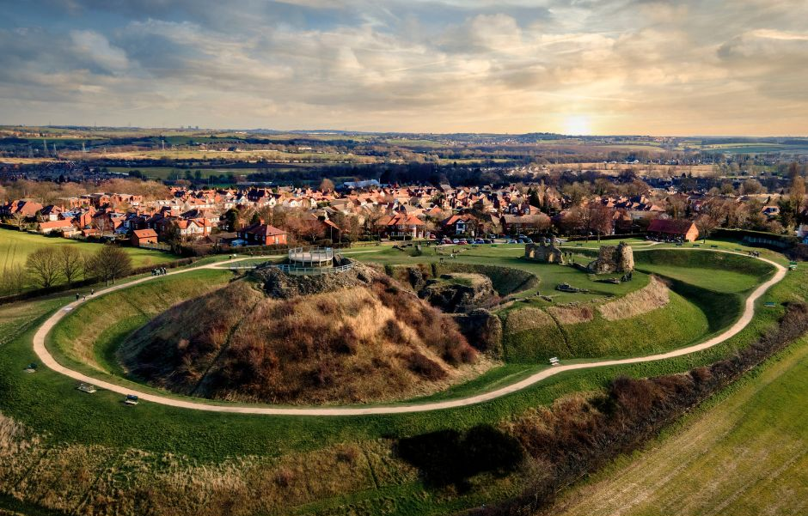
Forewords
I am pleased to share with you the Wakefield District Economic Wellbeing Strategy 2024-2029. Our vision is focussed on improving the wellbeing of our people and communities, by nurturing a just economy. Building on what works well and boldly tackling what doesn’t.
This Council understands the importance of looking after the wellbeing of residents, as well as the economy. Our Strategy will tackle long standing concerns within our district, whilst ensuring that the wellbeing agenda remains integral to everything we do.
Our primary focus is driving economic wellbeing for the residents of our district. For Wakefield Council, economic wellbeing is something which delivers social justice and a sense of belonging. It builds active participation and dignity for all of our residents. At the same time as driving inclusive and environmentally sustainable economic prosperity.
Implementing the Strategy, together with our partners, will help the Council form and prioritise the actions that will deliver this.
We have listened to what the people of this district and our partners need. We will continue to adopt a co-production approach between Council services and external partners in the public, private and voluntary and community sectors, in the knowledge that this will be the most impactful way to improve people’s lives.
I would like to thank everyone involved in this for their continued efforts and support. With this Strategy, we will maintain a clear focus on helping to create a fair, sustainable and future-focussed economy. With the wellbeing of all our residents at its heart.
Councillor Denise Jeffery
Leader of Wakefield Council

Our new Strategy provides our vision and strategic framework for the Council and its partners. It will guide delivery of activity towards achieving a wellbeing economy that benefits people in Wakefield over the next five years.
The Strategy allows the Council to focus on three core ambitions, underpinned by nine defined and impactful missions. These will deliver a culture of economic wellbeing for the Wakefield District. Our approach demands a step change in terms of the bold decisions we will need to make in order to drive the change that is required.
The Strategy has been informed by the most current economic challenges and opportunities and written to complement existing Council and regional strategies and plans. One of the priorities of the Wakefield Council Corporate Plan 2024-2026, ‘Building a Fairer Future’, is to deliver an economy that works for everyone, and our strategy has been designed to align with this priority.
The Strategy is a natural continuation from the Council’s previous commitments to good and inclusive growth, with a narrower focus on addressing the biggest issues which materially impact on people’s lives today and driving that change in a way which supports a greener, healthier planet.
I firmly believe that this Strategy will help us to deliver projects that Wakefield can be proud of and will make a big difference to people’s lives.
Councillor Michael Graham
Portfolio Holder for Regeneration and Economic Growth

Guiding Principles
Wakefield is recognised for its strong towns and communities. The work arising from the Strategy will differ between places according to local need, focusing on inclusion.
Wakefield promotes fair employment to ensure residents will work in better paid, rewarding jobs. Work with businesses locally will be focussed on those who support Fair Employment principles.
It is a key aim of the Council that residents live longer, fulfilled and healthier lives. The Strategy recognises that education, training and good employment are major contributors to achieving this aim.
The Strategy will provide increased opportunity for all Wakefield’s residents and will target support at those who need it the most.
The need to reduce carbon emissions underpins the Strategy. The least carbon intensive approach will be selected to deliver each mission.
Creative industries will provide a large amount of employment in the District in the coming years and help tell Wakefield’s story, so this sector is recognised as being important in creating change for good.
Wakefield Council will work collaboratively with partners across the public, private and third sectors to drive delivery of the Strategy. The Local Authority’s role will vary according to the work required as illustrated opposite.
The Different Roles of a Local Authority
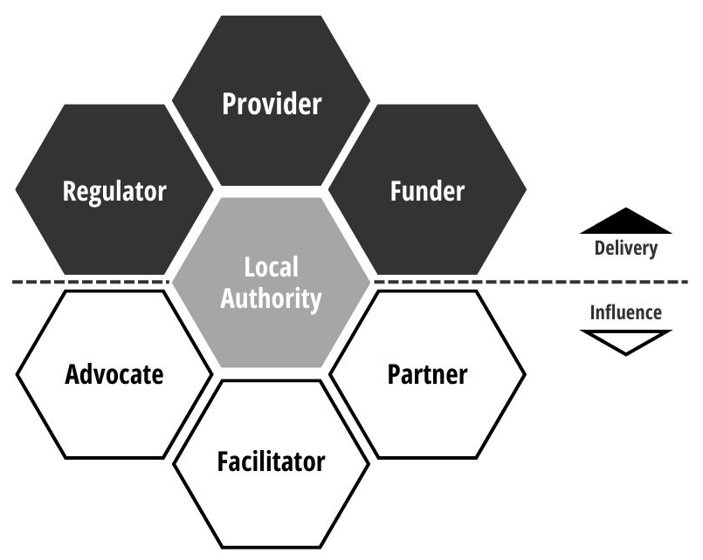
The big conversation told us that residents want...
Residents want:
- A greater range of employment opportunities across Wakefield including more high value jobs.
- To provide the existing workforce and young people with the skills to access new job opportunities and deliver these in partnership with business.
- To provide high quality housing but preserve green spaces, improve infrastructure, and ensure all organisations contribute to the communities of the District.
Our ambitions:
- Deliver a just transition for Wakefield’s carbon intensive businesses and springboard our key industries of the future.
- Generate high-quality and rewarding employment for Wakefield’s growing population.
- Drive more Wakefield businesses to work for the benefit of Wakefield.
Learn more: https://bit.ly/TheBigConversationWF

Wider Alignment
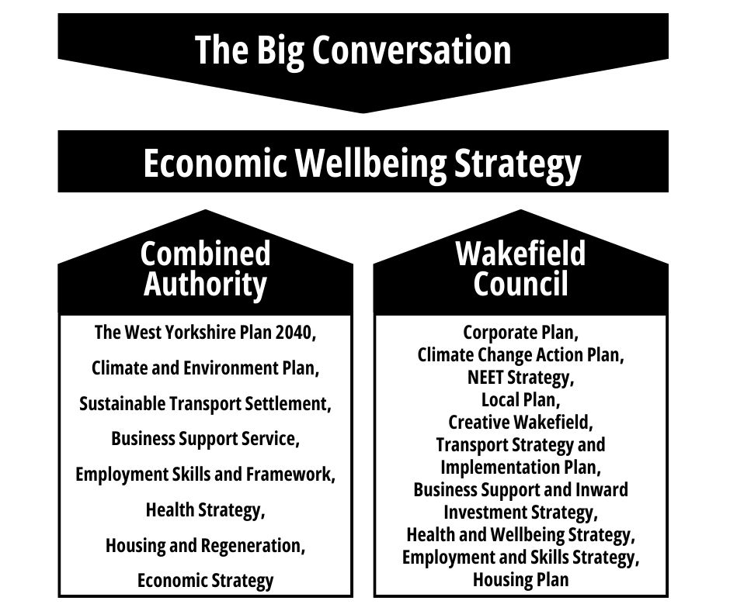

Summary
Vision: To improve the wellbeing of people and communities in the Wakefield District by nurturing a just economy which builds on what works well and boldly tackles what doesn’t.
Ambition 1
Deliver a just transition for Wakefield’s carbon intensive businesses and springboard our key industries of the future.
Missions
1. Grow our key quality sectors: health and social care, digital and low carbon
2. Drive better jobs and a just transition within transport, warehousing and manufacturing
3. Stimulate community led economic development and ownership
Results
• Quality growth sectors • Better jobs and more sustainable businesses • Greater capacity in communities to support local people
Ambition 2
Generate high-quality and rewarding employment for Wakefield’s growing population.
Missions
4. Ensure employers prepare the next generation for quality jobs in health and social care, digital and low carbon
5. Ensure providers are ready to give young people the skills they will need in health and social care, digital and low carbon
6. Empower schools and young people to shape future careers and drive aspiration
Results
• Better career prospects for local people
• Business growth enabled by better skills provision
• Wider participation of our young people in Wakefield businesses
Ambition 3
Drive more Wakefield businesses to work for the benefit of Wakefield.
Missions
7. Redirect more spend from Wakefield businesses back into the District
8. Better connect more local people to quality jobs
9. Increase private funding to stimulate regeneration and job creation
Results
• More business opportunities and supply chains created locally • More local people can access quality employment opportunities • More investment is made in our places
Outcomes
- Increased earnings
- Reduced deprivation
- Reduced health inequality
- Thriving communities
- Higher quality environment

Ambition 1
Deliver a just transition for Wakefield’s carbon intensive businesses and springboard our key industries of the future.
Strengths:
• Creative and Digital Sector. Wakefield hosts key creative and digital assets and it is growing fast with 5,000+ employees.
• Low Carbon Sector. Transition to net zero drives industry change, creating opportunities in clean energy, transport electrification, retrofitting, the circular economy and new skills.
• Health and Social Care Sector. Wakefield’s largest sector, with nearly 25,000 employees.
Missions:
1). Grow our key quality sectors: health and social care, digital and low carbon. We will
deliver business support and investment programmes that focus on the growth of our health and social care, digital and low carbon sector businesses, whilst attracting more employers into our District.
2). Drive better jobs and a just transition within transport, warehousing and manufacturing. We will drive the adoption of Fair Employment Charter principles and low carbon practises in the transport, warehousing and manufacturing sectors.
3). Stimulate community led economic development and ownership. We will support community development and ownership models for the growth of voluntary sector delivery organisations, social enterprises and cooperatives.
Results:
Quality growth sectors
Wakefield’s larger businesses will stay, adapt, and invest, whilst new employers will be attracted to bring more high-quality employment to the area.
Better jobs and more sustainable businesses
Sectors employing the highest number of people will create better quality jobs and become more sustainable, through their ability to attract and retain staff.
Greater capacity in communities to support local people.
There will be greater capacity to deliver with communities, make more local services available and widen the range of employment opportunities.

Ambition 2
Generate high-quality and rewarding employment for Wakefield’s growing population.
Strengths:
• Growing population. The working age population of Wakefield is set to grow by 8% by 2035 – placing Wakefield in the top 20 in the UK, ahead of its competition in attracting new businesses.
• Partnership working. Next generations will benefit from novel skills pathways developed in partnership with new organisations.
Missions:
4). Ensure employers prepare the next generation for quality jobs in health and social care, digital and low carbon. We will encourage businesses in the health and social care, digital and low carbon sectors to offer high quality jobs, define their future needs and lead the way in preparing our young people for these opportunities.
5). Ensure providers are ready to give young people the skills they will need in health and social care, digital and low carbon. We will ensure young people are equipped with the skills they will need, to be ready for opportunities in the health and social care, digital and low carbon sectors. Engagement with employers will ensure that gaps can be identified in the provision of employment and skills services at a local level, including apprenticeships.
6). Empower schools and young people to shape future careers and drive aspiration. We will listen to young people’s aspirations and provide career information and inspiration. A wide scale and proactive business in education programme will build up the knowledge of employment opportunities for young people throughout their school lives, whilst ensuring we create jobs that are considered high-quality and rewarding.
Results:
Better career prospects for local people
Prospective employees are clearer on what a career in their sector could look like. Employers can re-examine how to create good jobs and attract and retain their workforce by offering better career prospects for local people.
Business growth enabled by better skills provision.
There is direct alignment between the likely future skills needs of key sectors and addressing existing gaps with training providers in order to provide better skills provision to enable business growth.
Wider participation of our young people in Wakefield businesses
Young people are fulfilled and better informed than ever before about the opportunities available through local employment. Employers will be better connected to the workforce of the next generation.

Ambition 3
Drive more Wakefield businesses to work for the benefit of Wakefield.
Strengths:
• Local investment. The Wakefield economy is worth approximately £7bn. There is a large opportunity to be gained if more of this total economic income can be sustainably spent﻿ and invested locally.
Missions:
7). Redirect more spend from Wakefield businesses back into the District. We will understand the biggest areas of spend of our larger public and private sector employers and support our SME businesses to be more successful in meeting these opportunities.
8). Better connect more local people to quality jobs. We will influence improvement to connections and active travel across the District, to ensure that all residents have greater access to employment opportunities, by coordinating financial contributions through private and community led models of transport in areas with high concentrations of employment and limited transport connections.
9). Increase private funding to stimulate regeneration and job creation. We will secure more investment to finance the regeneration of our places by introducing priority projects to institutional and private funders. Where projects are approved, we will ensure that planning gain is maximised and re-invested.
Results:
More business opportunities and supply chains created locally.
More business opportunities created locally, with greater levels of business spend redirected locally between organisations within the District.
More local people can access quality employment opportunities.
Those areas most impacted by poor public transport provision and connectivity will have additional services including active travel links, to connect them to quality employment opportunities.
More investment is made in our places.
The total funding available to improve our places will be increased.

