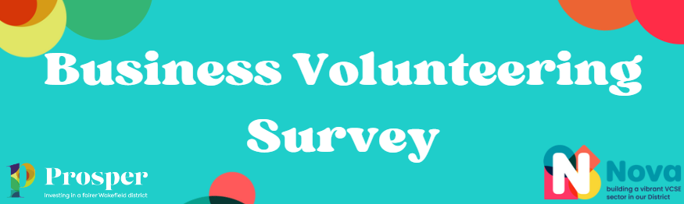

Here at Prosper, we are passionate about looking at the many different ways in which we can support charities and organisations across the Wakefield district. We know that many charities rely on volunteers to support the work they do and we are looking to work with organisations to identify what skills can be shared.
We are asking businesses across the district if they could offer their time and skills to the VCSE sector and this could be anything from a one-off team building day, an advice session to a charity or a more regular commitment.
We are working with our local charities to see what volunteering opportunities they have to offer and will match your companies’ skills with these placements.
Some examples are:
· Social media and digital marketing
· Graphic design
· Helping at events
· Giving advice sessions to families on a specific topic
· Bid writing
· Becoming a Trustee
· Offering a free or discounted service
……….whatever skill you have to offer, we’d love to hear about it!
By sharing skills across the VCSE sector, you’d be making a huge impact to the charities and organisations who we work with.
We would appreciate it if you could take a few moments to complete our survey so that we can collect data around the different skills which you or your business could offer.

Name

Position in Company

Company Name

Company Address

Geographical Area

Email Address

Telephone Number

Has your company ever taken part in volunteering?

Who was the volunteering for?

What was the role?

How many hours did you give?

Would you be interested in registering your company to take part in volunteering for local charities? YES/NO
What types of volunteering would your workforce be interested in (please tick all that apply)?
- Helping at charity fundraising events
- Team building days (gardening, painting and decorating etc)
- Mentoring charities
- Bid writing
- Giving advice to charities
- Workshops
- Becoming a Trustee
- Other (please give a brief explanation):
How many hours per week/month could you give?:
Could your business offer a space for charities to meet on a regular basis? This could be weekly/fortnightly/monthly? If so, please give details:
Could your business offer to donate goods/surplus stock for us to distribute to local charities and organisations? If so, please give details:
Thank you for taking the time to complete this survey, we will be in touch with further information.
Prosper Wakefield District will use the information you provide on this form to contact you with regards to volunteering and other opportunities which you may wish to support. We will also share your information with Nova Wakefield District.
Please get in touch at julie@prosperwakefielddistrict.org if you wish to unsubscribe at any time.

